## Lab 7-01: Simple Deployment

### Lab Prerequisites

* Familiarity with basic Google Cloud Computing concepts and terminology.
* A Google account with an active subscription.

### Service Introduction

The simplicity of setting up a new web hosting solution is a major benefit of Google Cloud hosting. More than 100 click-to-deploy web hosting solutions are available through the service, substantially simplifying the setup and launch procedure.

### Case Study Plastic manufacturers – FuturePlast

Background

FuturePlast is a plastic manufacturing company that produces a wide range of plastic goods for different industries. They specialize in creating durable, high-quality plastic products using the latest technologies and materials.

Although FuturePlast has been successful in manufacturing plastic goods, they have yet to establish an online presence. They are now looking to deploy a website through Google Cloud Platform (GCP) to address this issue. This move will help them to showcase their products and services to a wider audience and increase their reach and sales.

By deploying its website on GCP, FuturePlast can take advantage of the platform's cloud infrastructure and tools to improve its website's performance, scalability, and security. GCP offers various features such as auto-scaling, load balancing, and built-in security to ensure that their website runs smoothly and securely.

### Business Challenge

Deploying a website is straightforward for anyone with an IT background, but it is extremely complex for a plastic manufacturer. They are looking for a Cloud Architect to understand their requirement and suggest a solution.

### Proposed Solution

You have suggested that they take the simple route and deploy their website through a VM instance. It is scalable, redundant, and easy to manage.

Lab Diagram

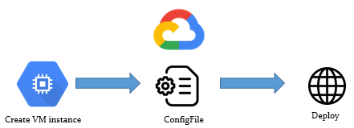

Figure 7-04: Lab diagram

Implementation Steps

1. Create a VM instance.
2. Deploy using config file.
3. Check the deployment.

Solution

1. Open “Cloud Shell”.
2. Go to “Compute Engine”, click “VM instances”, then click “CREATE INSTANCE”.

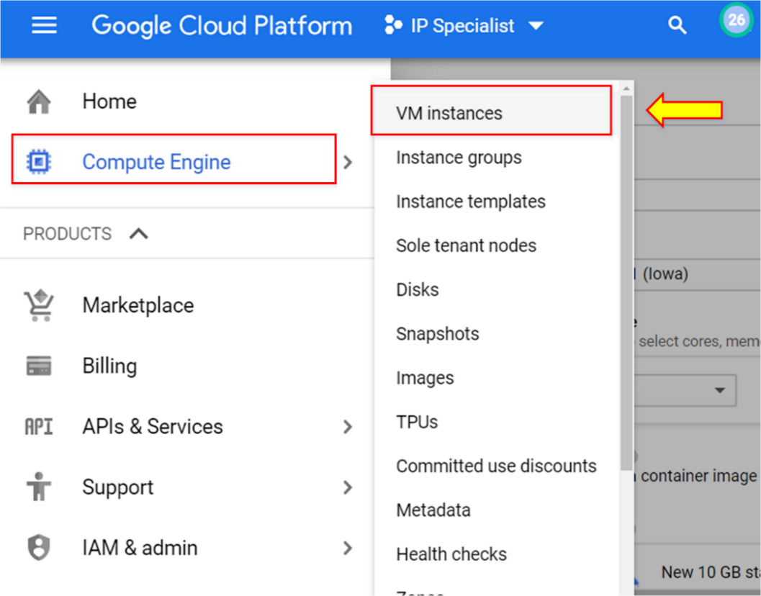

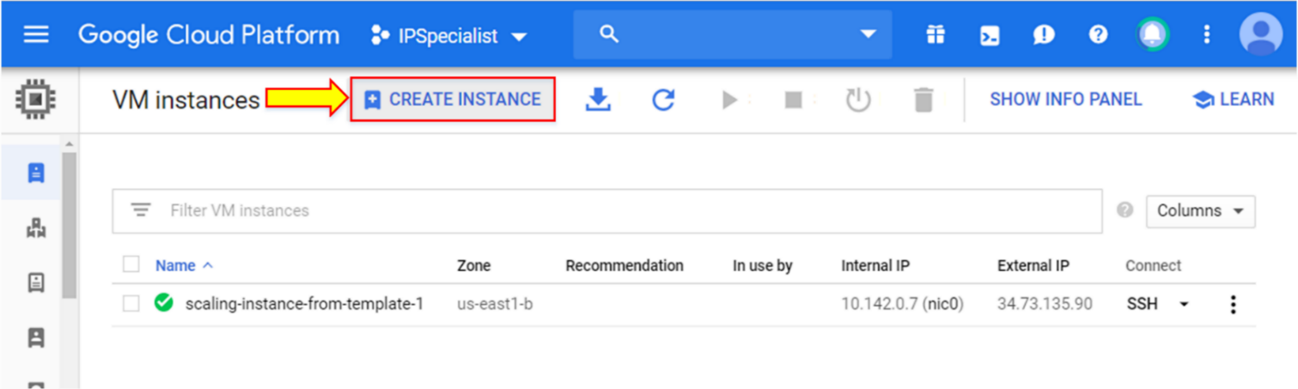

1. Scroll down to the bottom of the window and click “REST”.

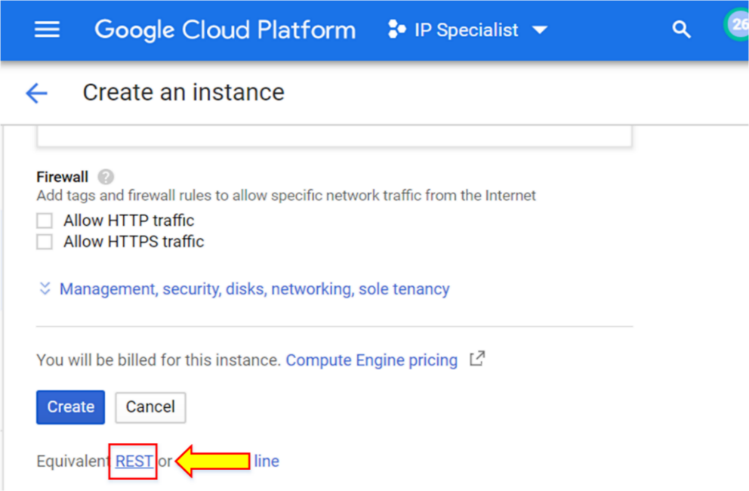

This will show you the default format of the “configuration.yaml” file. It will be in JSON format, which you must change to YAML using any convertor.

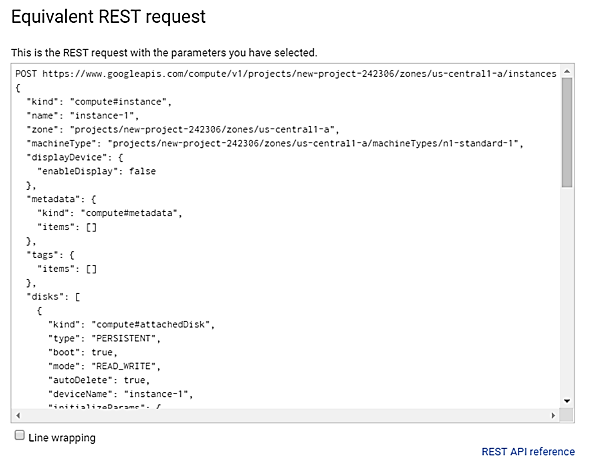

1. Enter the command “git clone <https://github.com/IPSpecialist/GCP_Professional_Cloud_Architect>” for the configuration files and templates used in this project.
2. Open the editor window.

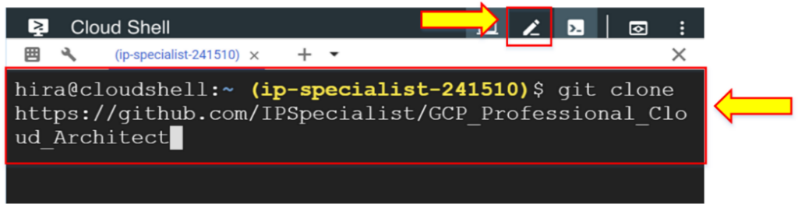

1. Click ‘vm-web.yaml’.

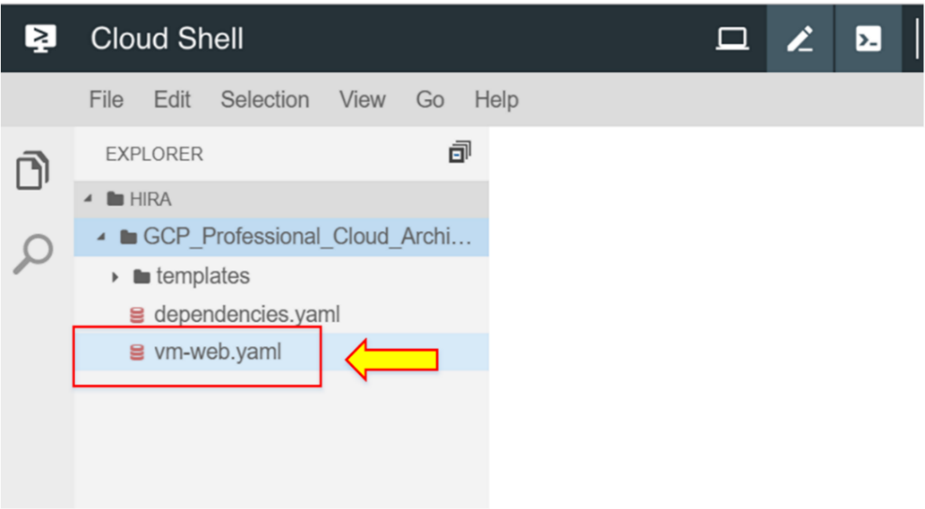

1. Replace “YOUR_PROJECT” with your project ID. Two replacements are shown in line 8 and line 31.

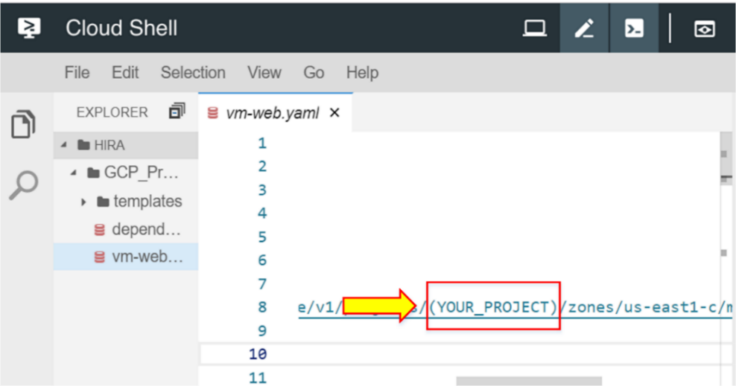

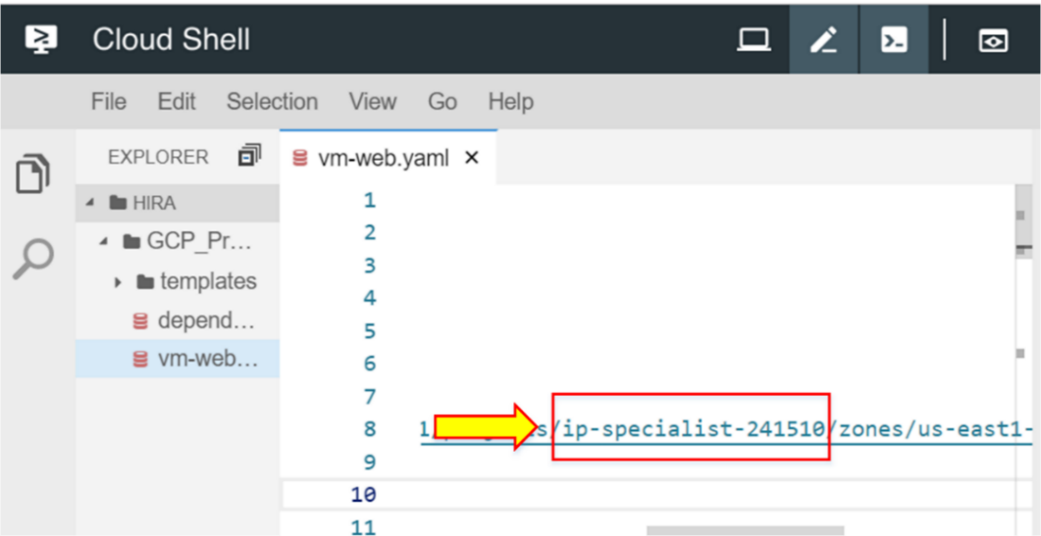

1. Enter the command “cd GCP_Professional_Cloud_Architect” to move in the directory.

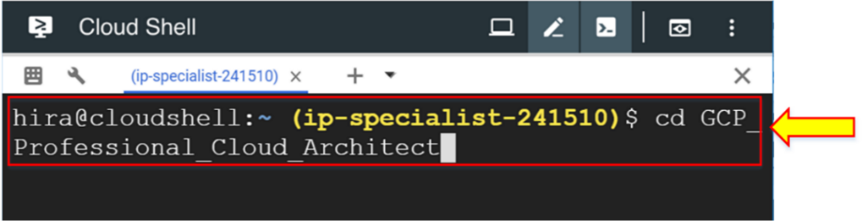

1. Enter the command “gcloud deployment-manager deployments create single-vm --config vm-web.yaml” in Cloud Shell.

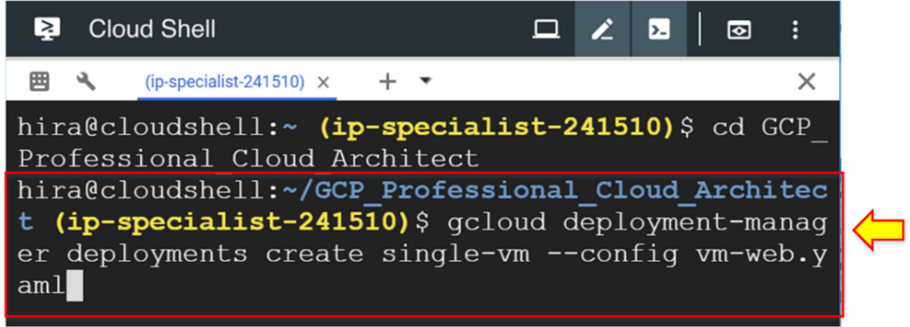

1. Enter “y”.

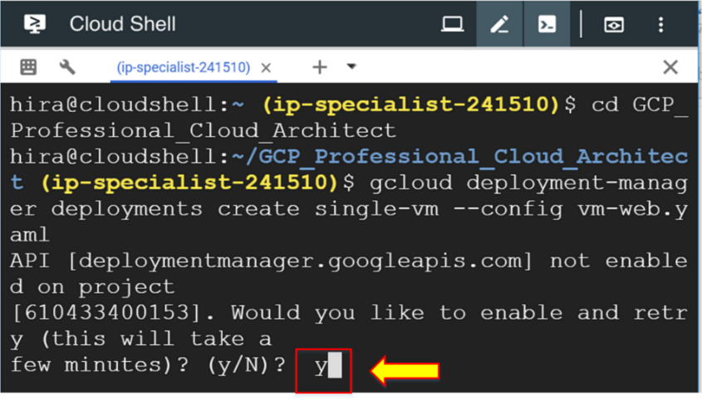

1. Go to the web console in “VM instances” to verify that the instance is created. Click the external IP.

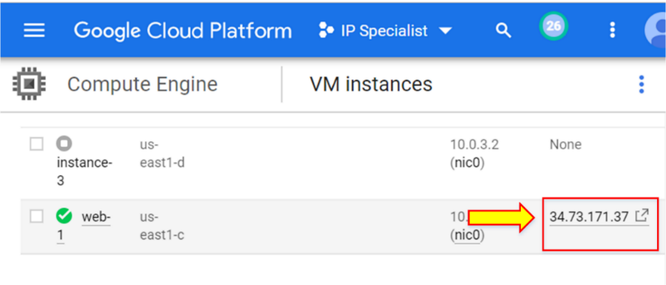

It is successfully launched.

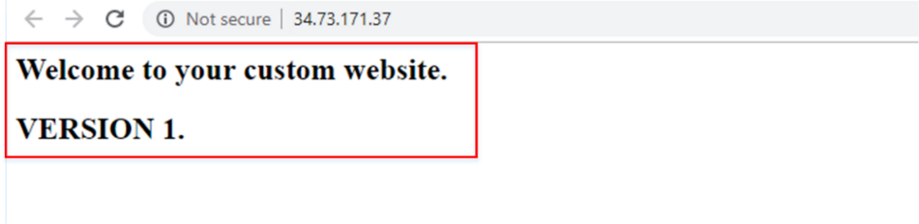

1. Now, go to “Deployment Manager” to delete the deployment.

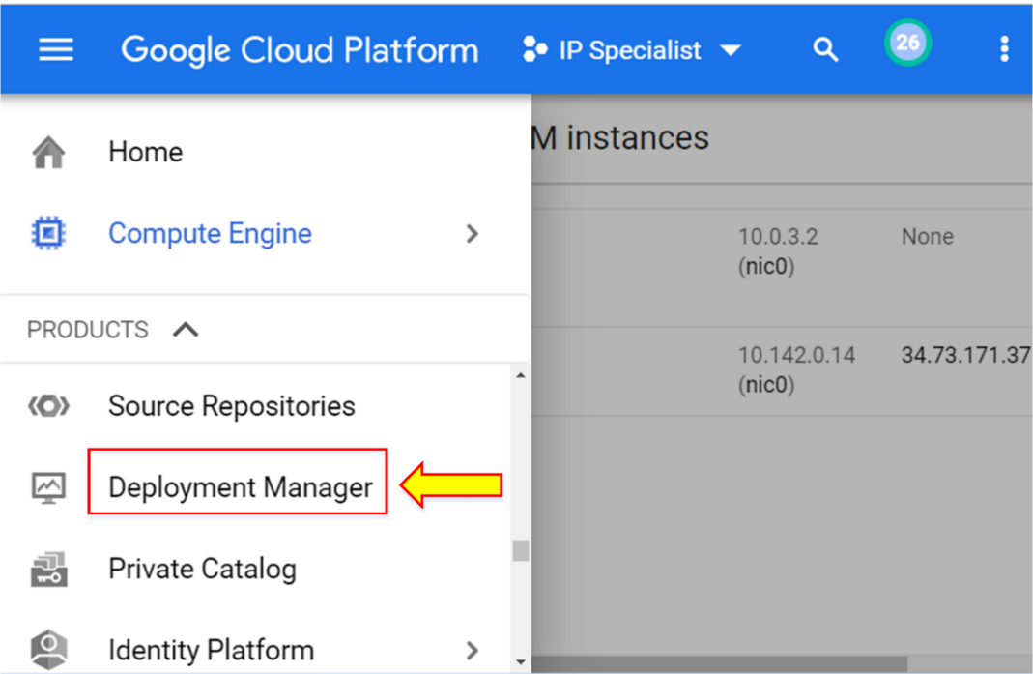

1. Select your deployment and delete it.

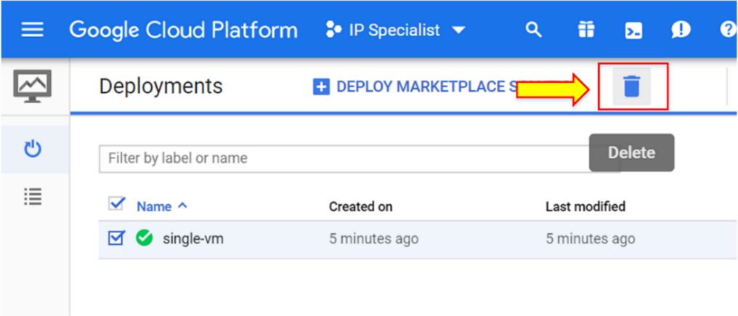

1. To view the output of deployment before the actual deployment, enter the command "gcloud deployment-manager deployments create (deployment_name) --config (config_file.yaml) --preview".

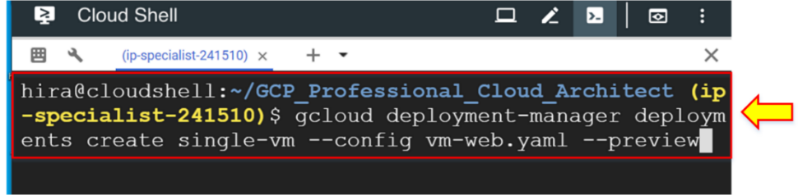

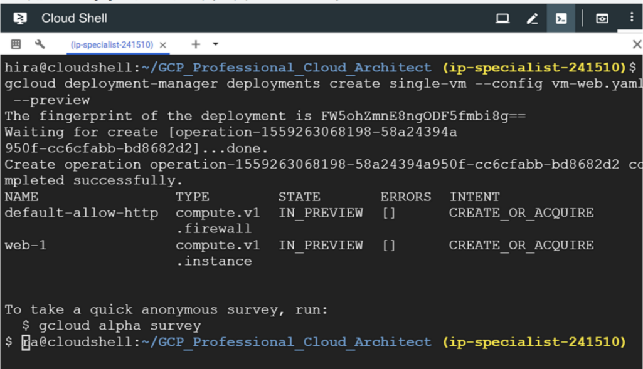

1. Go to “Deployment Manager”.

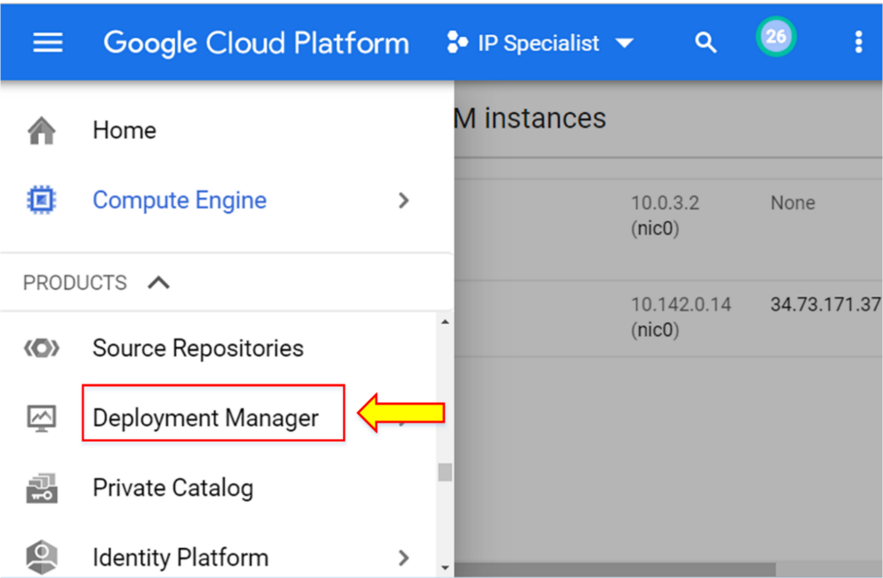

Here is the deployment with a different symbol that represents the preview mode of the deployment.

1. Click the preview mode deployment.

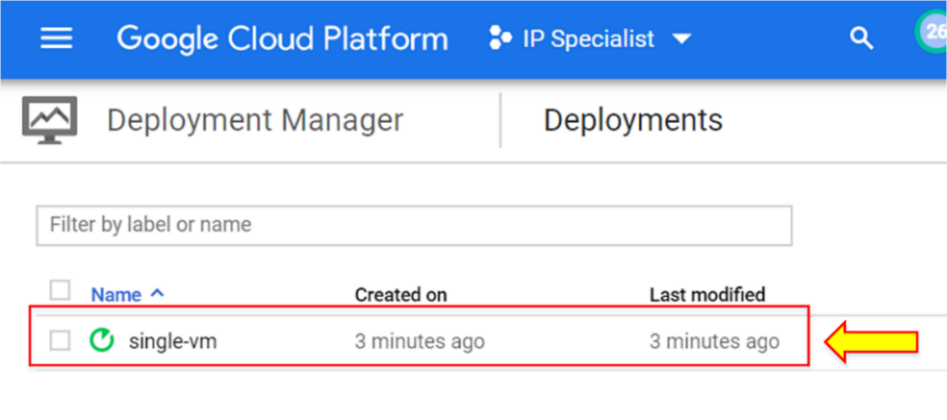

1. To deploy the deployment in preview mode, enter the command "gcloud deployment-manager deployments update (deployment_name)" or click “Deploy” in the web console.

